User Manual

Version UM-2-2014-05-28

For

PlasmaGraph

|  |  |  |
| --- | --- | --- |
| Daniel E. Quintin |  | Gerardo A. Navas |
| Computer Science Undergraduate Program |  | Computer Science Undergraduate Program |

Polytechnic University of Puerto Rico

Electrical & Computer Engineering and Computer Science Department

May 28, 2014

Revision History

|  |  |  |  |
| --- | --- | --- | --- |
| **Name** | **Date** | **Reason For Changes** | **Version** |
|  |  |  |  |
|  |  |  |  |
|  |  |  |  |

Table of Contents

1. Introduction 1

1.1 Getting Started 1

1.2 Audience 1

1.3 User Interface 1

2. Product Functions 5

2.1 Create Graph 5

2.2 Save Graph 10

2.3 Using Templates 11

2.4 Inspecting Data 12

2.5 Revising Data Files (Programmers) 13

3. References 14

4. Table of Figures 15

# Introduction

## Getting Started

PlasmaGraph is a software tool designed for optimizing the process of gathering and analyzing output data produced by the mirror and cusp plasma machine at the PUPR by letting the user generate graphs with this data. In other words, PlasmaGraph uses data files produced by the plasma machine in order to generate graphs that can be saved as images in the user’s personal computer.

## Audience

This document is intended for researchers interested in using PlasmaGraph for analyzing data and programmers tasked with fixing corrupted data files produced by the plasma machine.

## User Interface

Its primary function is to enable users with no programming skills to produce graphs from data files made in the plasma laboratory. This is accomplished by presenting the user with a series of windows, buttons, and input fields that he or she can use to order PlasmaGraph what to do. The following sub-sections will explain in more depth each one of these elements and their role in the overall program.

### Tools Pane

This is where the user will do most of the input. The tools pane is used to import data or template files into the system, save template files, view data files, set the graphs type, graph title and axis’s labels, and determine which pair of data columns is to be graphed and if the values should be grouped using a third column as reference. In addition, the user can order the system to produce the graph using one of three different kinds of interpolations (linear, quadratic, or spline) and whether it should scan for outliers before producing the graph **[see figure 1-1]**.

Figure 1‑1: Tools Pane

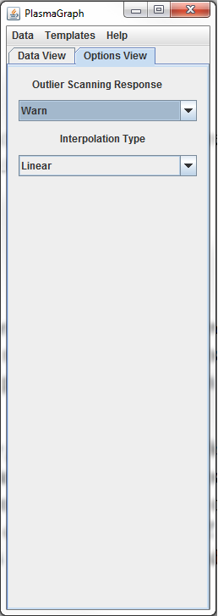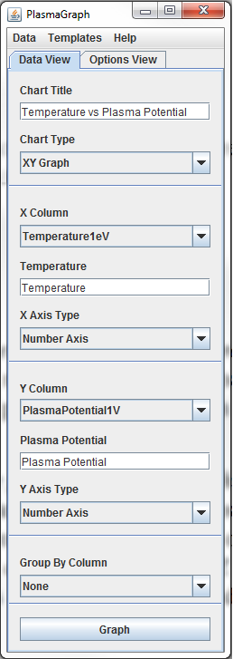

### File Chooser

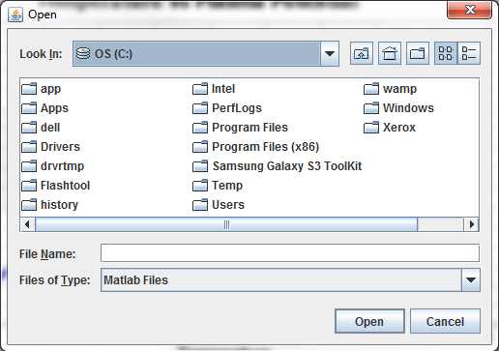It is used to navigate and select items in the file system of the user’s personal. With this window the user can select template or data files to load into the system. Also, this window is used to choose where to save template files and graphs images. ***[See figure 1-2]***

Figure 1‑2: File Chooser

### Data Pane

This component is used to display the contents of a data file in a way that is readable by the user ***[see figure 1-3]***.

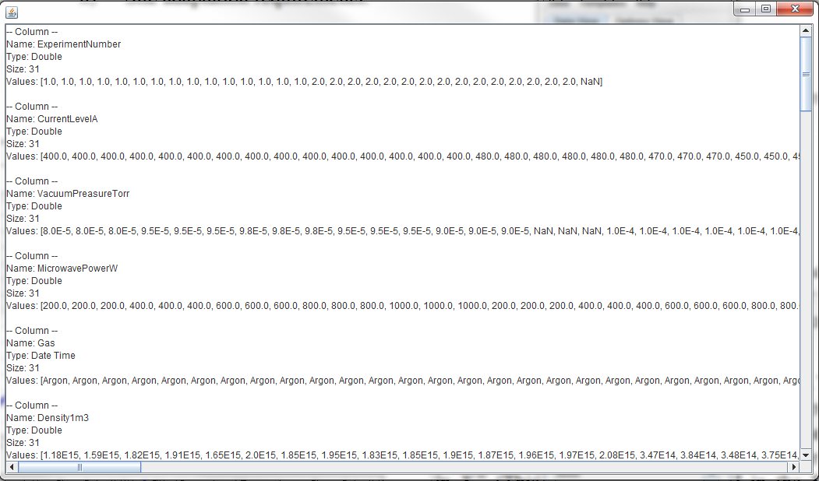

Figure 1‑3: Data Pane

### Options Pane

They are windows for transmitting messages to the user and in some cases elicit an option from him or her ***[see figure 1-4]***.

Figure 1‑4: Option Panes

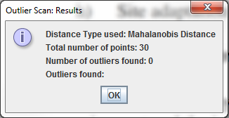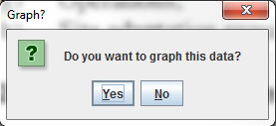

### Graph Pane

This is the portion of the program where the graph is displayed. It can also be used to save the graph in the user’s computer ***[see figure 1-5]***.

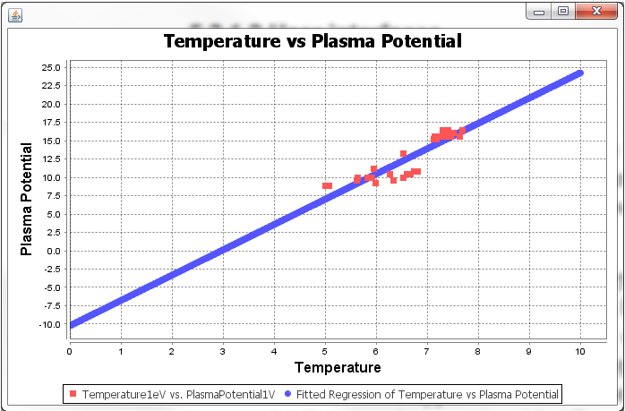

Figure 1‑5: Graph Pane

# Product Functions

## Create Graph

### Importing the Correct Data File

The first thing you must do in order to create a graph is import a data file. For PlasmaGraph a data file is a binary MATLAB Level 5 MAT-File [19]. This type of file is produced by the Mirror Cusp Plasma Machine and in some cases it can be revised and adjusted by a researcher with skills in MATLAB programming language ***[See section 2.6]***.

To import a data you have to click on the *“data”* option located in the tools’ pane upper menu. After doing this a new menu with two more options will appear. Click on the option that says “Import Data”. This will open a file chooser. Use it to browse your computer and select a data file.

Figure 2‑1: Importing Data

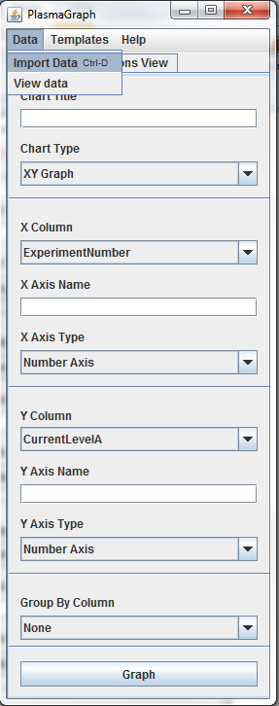

### Creating a Graph

Once you imported some data into the program we can start creating graphs. The first step is to set the name of the graph. To do this you must click on the blank text field under the *“chart title”* option located in the tools’ pane *“data view”* tab and write the name of the graph. Similarly, you can click under the options “X axis name” and “Y axis name” to set the name of each label accordingly.

After setting the graph’s labels you will have to choose which values to plot on the X axis and which values in the Y axis. To do this you must click on the *“X column”* option located in the tool bar and choose one data set for the X axis. The same process applies to the Y axis. Finally click on *“Graph”.*

Figure 2‑2: Creating a Simple Graph

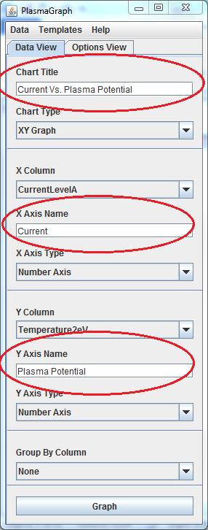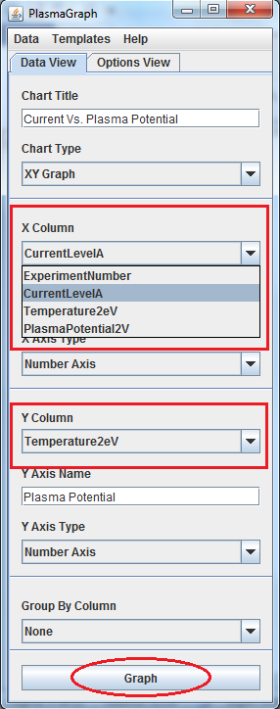

### Interpolation and Data Confidence Level

To interpolate the graph you must click on the *“options view”* tab located in the tools pane. The click on the “interpolation type” field and choose one of the interpolations available and then click *“graph”*. When the program interpolates a graph it will also determine its confidence level.

Figure 2‑3: Interpolation and Data Confindence

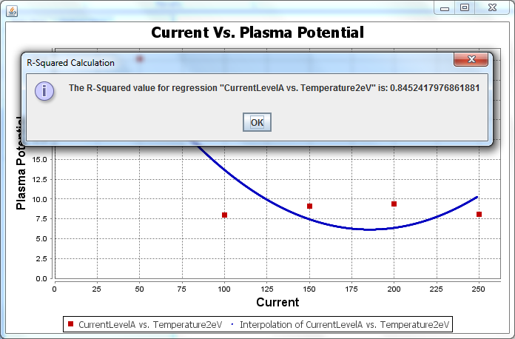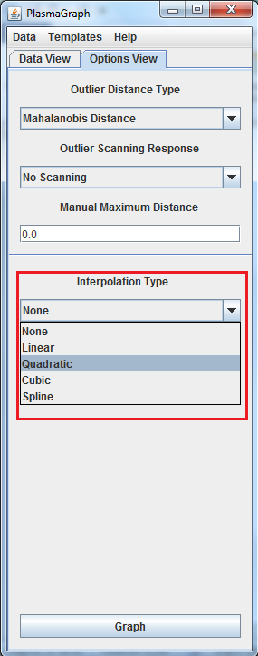

### Outlier Detection

This program can automatically detect outliers using either the “Mahalanobis distance” [2] or a user provided distance. To enable this feature click on the tools’ pane “options view” tab and select an outlier distance type and scanning response. If you chose a user provided distance you must specify that distance under “manual maximum distance”.

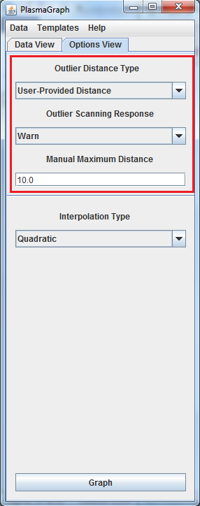

Figure 2‑4: Outlier Detection

### Grouping and Axis Types

Another feature of this program is that it can be used to graph two sets of values grouped by a third set of values. The condition is that the set used for grouping has to have at least two repeating values. To create a graph grouped by a third set click on the tools’ pane *“data view”* tab and select one set from the *“group by column”* option.

Also, you can set the axis type to logarithmic or numeric using the “X axis type” and “Y axis type” options.

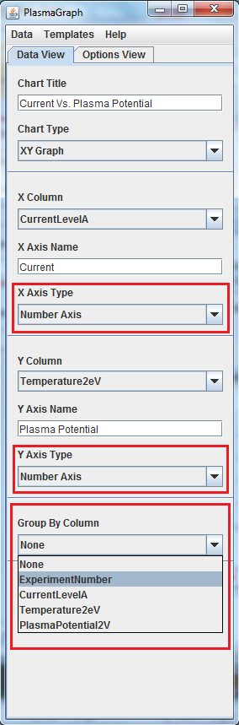

Figure 2‑5: Grouping

## Save Graph

To save a graph you must first create a graph ***[see section 2.1]***. Then right click on the graph pane and select “save as >> PNG…”. A file chooser will open. Use it to select where to save the graph and what name it must have.

Figure 2‑6: Saving a Graph

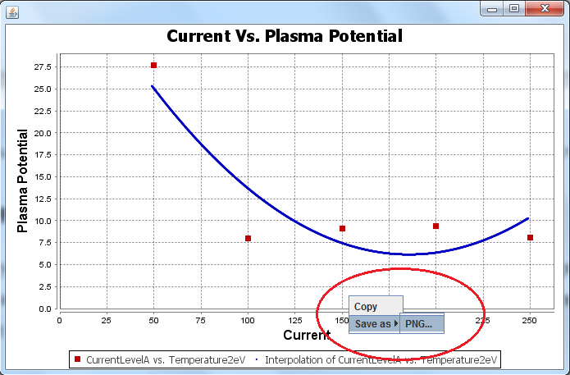

## Using Templates

A template is a pre-made graph configuration that can be saved so you can use it later. For example if you make a graph with certain title, axis name, interpolation type etc. and you want to repeat that graph with data for more than one file. You could use a template to pre-set all the options of the graph so the only thing you have to do is select a template, select a data file and click on *“graph”*.

### Creating a Template

To create a template, first select all the options of the graph. Then select the option *“Templates >> save template”*. Use the file chooser to select where to save the template and how it must be named.

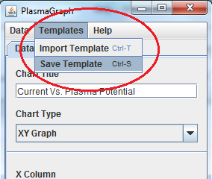

Figure 2‑7: Saving a Template

### Import a Template

To use a template you must select the option *“Templates >> import template”* located in the tools’ pane upper menu. Then you must use the file chooser to browse your computer and select a data file.

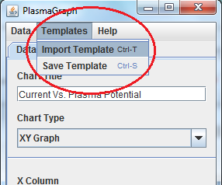

Figure 2‑8: Importing a Template

## Inspecting Data

To view the values contained in a data file imported you have click on the “Data >> view data” option located in the tools’ pane upper menu.

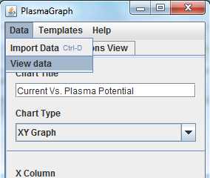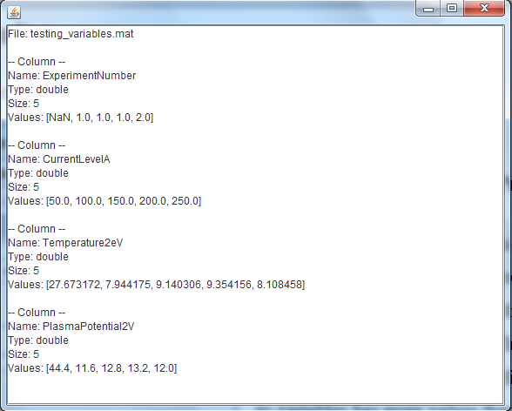

Figure 2‑9: Inspecting Data

## Revising Data Files (Programmers)

One limitation of this program is that it can only plot points where there’s a one to one relationship between the values selected for the X axis and the values selected for the Y axis. This means that if the plasma machine produces a file where one of its variables has more values than the rest. Then PlasmaGraph will not be able to create a graph with that file. In that case, or in any other case where the program reports some kind of error regarding data. The programmer must open the file with MATLAB and make sure that it complies with the following specifications:

1. The file must contain at least two variables.
2. All variables must be vectors with the same amount of values.
3. Permitted data types are: NaN, double, char or cell. [3]
4. All vectors must have at least one value and every value in a vector must be of the same data type.
5. For performance reasons the file size must be 56300KB or less.

# References

|  |  |
| --- | --- |
| [1] | The MathWorks, Inc., "MATLAB MAT-File Format R2013b Figure 1-1," [Online]. Available: http://www.mathworks.com/help/pdf_doc/matlab/matfile_format.pdf. [Accessed 21 1 2014]. |
| [2] | P. C. Mahalanobis, «Proceedings of the National Institute of Sciences of India,» 1936. [En línea]. Available: http://www.new.dli.ernet.in/rawdataupload/upload/insa/INSA_1/20006193_49.pdf. [Último acceso: 27 05 2014]. |
| [3] | The MathWorks Inc., «Data Types,» [En línea]. Available: http://www.mathworks.com/help/matlab/data-types_data-types.html. [Último acceso: 24 1 2014]. |

# Table of Figures

Figure 1‑1: Tools Pane 2

Figure 1‑2: File Chooser 3

Figure 1‑3: Data Pane 3

Figure 1‑4: Option Panes 4

Figure 1‑5: Graph Pane 4

Figure 2‑1: Importing Data 5

Figure 2‑2: Creating a Simple Graph 6

Figure 2‑3: Interpolation and Data Confindence 7

Figure 2‑4: Outlier Detection 8

Figure 2‑5: Grouping 9

Figure 2‑6: Saving a Graph 10

Figure 2‑7: Saving a Template 11

Figure 2‑8: Importing a Template 11

Figure 2‑9: Inspecting Data 12